**Members**

Lisa Chen

**File Listing**

* **search.py** 
  + File defining search algorithms
  + Only Uniform Cost Search (UCS) and A Star Search implemented with an added helper class Node I created outside of the original defined methods/classes

**What I’ve learned**

I learned a little bit more about coding efficiently and updated my old code to make it better. In addition, I used the algorithm from the book and tweaked it based on how PriorityQueue was created by the original code. Due to the update(), it was a lot easier for me to not put too much conditionals since update() in PriorityQueue will automatically update a node in the queue if it is in the queue with a worse priority; if it is not in the queue, it will just push into queue like how the push() method works. Furthermore, because I changed the implementation a bit compared to BFS/DFS by using Nodes, I learned how to override the equal comparison for objects in Python.

Question 3: UCS - Pacman Terminal Prints

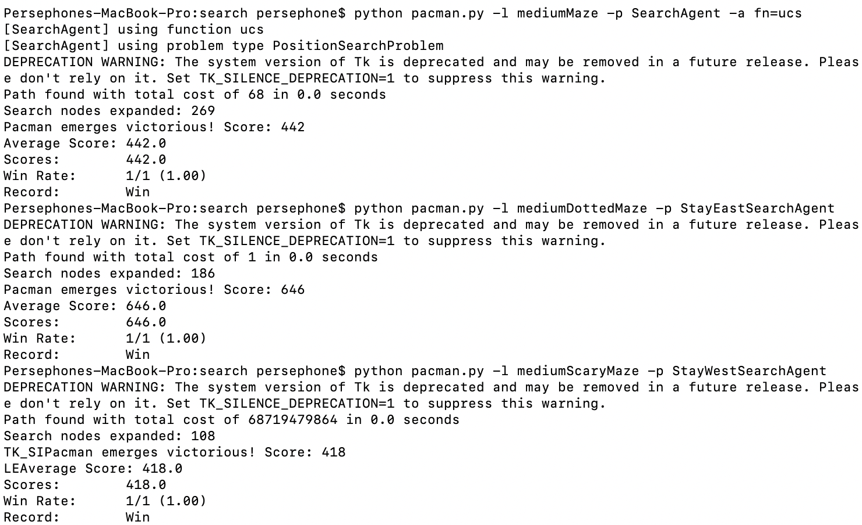

Question 4: A Star Search - Pacman Terminal Prints

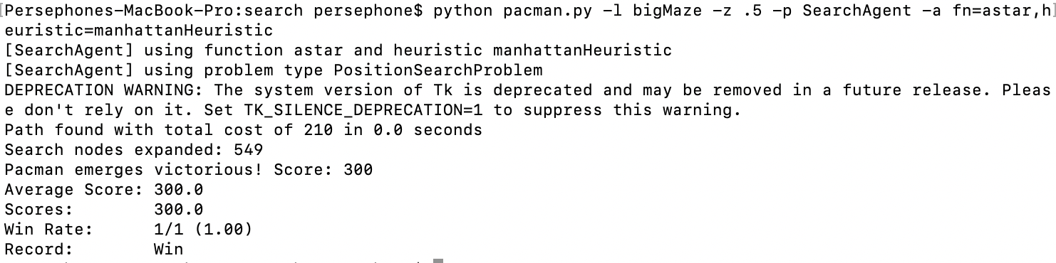

Autograder Question 3 (UCS)

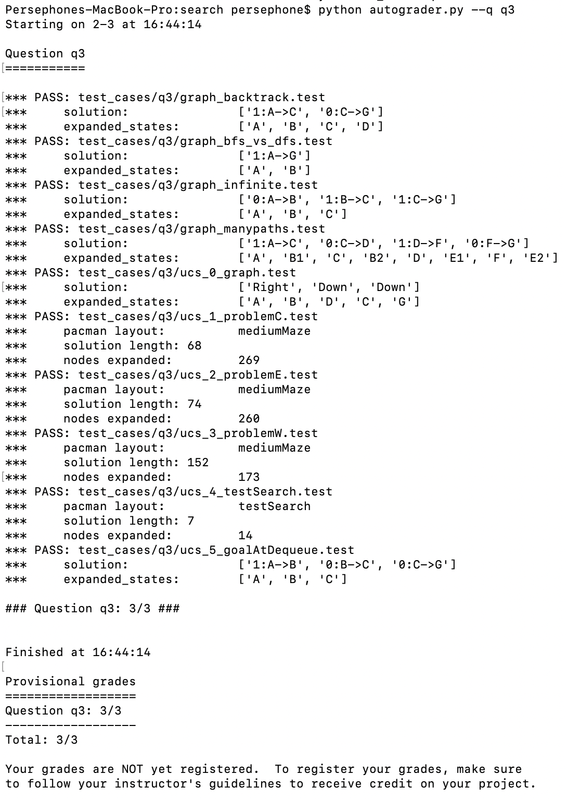

Autograder Question 4 (A* Search)

